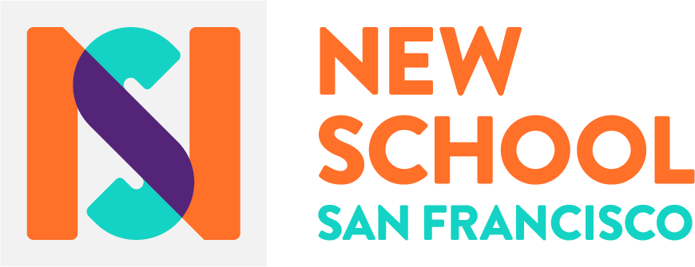
School Behavior Support
and Discipline Policy

School Climate
A Positive Learning Environment = Engaged & Joyful Learners.
In attending to the whole child, The New School of San Francisco will incorporate social emotional development into all aspects of teaching and programming. We view social emotional learning (SEL) as the process of identifying and applying skills to know oneself, setting and working towards goals, empathizing, building positive relationships, engaging in conversations about diversity and inclusiveness, and making responsible decisions.
In our founding year, we are focusing on 5 key values that are upheld by all students and adults at the New School of San Francisco. At the New School we are;
- Courageous
- Curious
- Kind
- Respectful
- Responsible
Throughout the year, students, staff and families will explore how these values fit into different aspects of our school community (i.e.- what does being courageous in the classroom look like? What does being responsible at lunch sound like? What does being kind at park feel like?) As a founding NSSF staff we have developed community agreements in honor of these community values. In classrooms, students and teachers will establish community agreements that reflect these values. At our Home & School Council and subcommittees, staff and families will also establish community agreements that live up to the five values we hold to as the New School San Francisco.

The Tools We Use: Restorative Practices, Social Emotional (SEL) instruction and Positive Behavior Interventions and Supports.
Restorative Practices (RP) are founded in building community first and foremost. You can’t restore a relationship if a relationship did not exist in the first place. Community and relationship building is integral to NSSF, which will make it that much easier to implement restorative practices (relationships will exist to be restored when needed). Studies have also shown that the stronger the community, the more students hold themselves and their peers accountable, and there is more of the community building and less of the restoring going on.
Key pieces to RP implementation at The New School of San Francisco
- All school staff trained in RP
- Use of RP continuum (circles, affective statements and questions, formal conferencing etc) will be used in all classrooms
- School wide care team for top tiered responses (3 tiers, (1) preventative, (2)support, and (3)intensive), and grade appropriate
- Parents and Students trained in RP
- Facilities; classrooms designed to have areas that serve as a “calm down” or “de-escalation” space. Use of space to promote learning circles.
Direct Instruction of Social Emotional Learning (SEL)
SEL is a focus at every grade level and a primary component of teacher development. We recognize that social emotional learning cannot be taught and exercised in bursts, but must be demonstrated and practiced continuously. The majority of explicit SEL instruction will take place through activities, individual and group conversations, and verbal transparency in Pod Time; however, SEL is also a mindset that all staff will be committed to modeling in every interaction: in the classroom, amongst staff, and in family and community relationships.
The Collaborative for Academic, Social, and Emotional Learning (CASEL) has created a framework that will be useful for the New School of San Francisco to build a common language around SEL guiding principles. Because SEL is unique to each child, these core competencies can be used by teachers to build their own SEL rubrics, to know what to look for in observation and narrative documentation about students’ personal growth, and to evaluate school wide SEL programs and evaluation methods.
Social and Emotional Learning Core Competencies:
- Self-awareness
- Self-management
- Social awareness
- Relationship skills
- Responsible decision-making
Positive Behavior Interventions and Supports (PBIS)
The use of PBIS allows us to move away from the traditional approach to school discipline (punitive) to an approach where there is less value placed on punishing inappropriate behaviors and more value on teaching and rewarding the behavior expectations that have been set and reflect our community values.
We will use a tiered PBIS model, recognizing that all children learn differently, and some may need more support than others. Below are examples of Tiers 1, 2 & 3 of interventions and supports that are in place and are currently being rolled out in our first year.
Tier 1 Interventions and Supports (for all students)
- Reminders and redirection  - Re-teaching of expectations  - Written reflection or apology  - Logical Consequences  - Behavior expectations lesson plans  - Affective Statements and Questions | - Classroom fun day, or choice time  - Shout outs, put ups, thanks  - School Wide and Classroom based expectations  - Community Building Circles  - School Wide point system and rewards  - Prize boxes
Tier 2 Interventions and Supports (extra supports, 10-15% of students)
- Restorative Circles  - Loss of classroom privileges  - Positive Behavior Intervention Plan  - Daily Star Chart  - Breaks  - Positive notes home  - Teaching conflict resolutions skills | - Referral to community provider  - Community service  - Calming Corners  - Small Group Instruction  - Frequent praise for pro-social behavior  - Academic Support
Tier 3 Interventions and Supports (Intensive, 3-5% of all of students)
- Intensive academic support  - Structured breaks throughout the day  - Behavior contract  - 1 on 1 direct support  - Intensive Social Skills teaching | - Check in /Check out  - Mentoring  - Counseling Referral  - Collaboration with Student physician and/or Mental health provider

Suspensions and Expulsion
Suspension will be very rare at the New School of San Francisco, and we will exhaust all other in-school opportunities before resorting to suspension. However, we recognize that extreme or dangerous violations of Ed Code may require it. In those difficult moments, Our CARE team along with intensive tier 3 supports will ensure that students are welcomed back into the school community in a manner that provides support to the child and family. The re-entry process will be meant to promote community healing as well as student learning and well-being.
There are only 5 behaviors that require a mandatory suspension as per Ed Code (on first offense). They are;
- Possessing, selling or furnishing a firearm
- Brandishing a knife at another person
- Unlawfully selling a controlled substance
- Possession of an explosive (or threat thereof ….see bomb threat)
- Committing or attempting to commit a sexual assault or committing sexual battery.
As per Ed Code these require a mandatory suspension. For all suspensions there will be a reintegration team (CARE team) and plan, restorative conferencing (if applicable) and restorative practices will be used for all affected students and staff (when applicable).
For other infractions that do not require automatic suspensions, tiered interventions and supports will be implemented both in and out of the classroom.

